ONLINE VEHICLE PARKING RESERVATION SYSTEM
Methodology, Novelty and Key Contributions
Department of Computer Science and Engineering, TKR College of Engineering & Technology
Batch C3 (CSE-C) · Academic year [ACADEMIC YEAR]
Table 1: Project team
S.No. | Student name | Roll number
1 | Palle Yashaswini | 23K91A05H9
2 | Mohammed Muneeb Ahmed | 24K95A0518
3 | Kamasani Manisha | 24K95A0513
4 | Pothagani Nithyya Bhargava | 23K91A05J6

Project guide: V Pallavi
Chapter and section numbers quoted in the text (for example Chapter 8 or Section 6.2) refer to the full project report, 17.Final Document. Figures and tables in this document are numbered from 1.

1. METHODOLOGY
This document describes how ParkSure works from end to end and what is new in it. Part 1 gives the pipeline, the data, the algorithms and the reasons they were chosen; Part 2 sets the work against the base paper and separates what is new from what is standard; Part 3 lists the contributions.

1.1 Overall methodology
ParkSure treats parking reservation as an admission-control problem with feedback. A request is a time interval at a location; the system admits it only if enough bays remain after the already admitted intervals and a hold-back buffer, checks physical space when the driver arrives, and judges the departure afterwards. The punctuality of each departure feeds two memories, the location's buffer and the driver's Trust Score, which shape later admissions and prices. The registered base paper [1] solves a different allocation problem (balancing passengers across zones), so the method follows the reservation, buffer and reward mechanism of [2] and builds the surrounding platform. The method has seven steps.
1. Register and authenticate. A driver registers with a name, e-mail and password (stored as a bcrypt hash) and receives a signed token; the first account on an empty database becomes the administrator.
2. Search. For a chosen window, count the reserved and active bookings that overlap it at each location and report the bookable bays, which are capacity minus buffer minus overlapping bookings.
3. Reserve. Refuse suspended drivers; admit the request only if overlapping bookings plus the buffer stay below the capacity; quote the fee; apply account credit; store the booking and the payment.
4. Pay. Create a Stripe Checkout session in test mode, or the offline demo checkout when no key is configured; mark the payment paid on confirmation.
5. Arrive. On check-in compare the bookings marked active at the location with its capacity. If the lot is full, book the single nearest other location whose own admission rule accepts the window, or mark the booking failed and credit the fee.
6. Depart. On check-out decide on time (within ten minutes after the end) or late; grow the buffer after an on-time departure; record a benefit or a warning and update the Trust Score.
7. Analyse. Replay the stored bookings under four buffer policies (Strategy Insights), and measure the rules with a simulator that was checked against the engine.
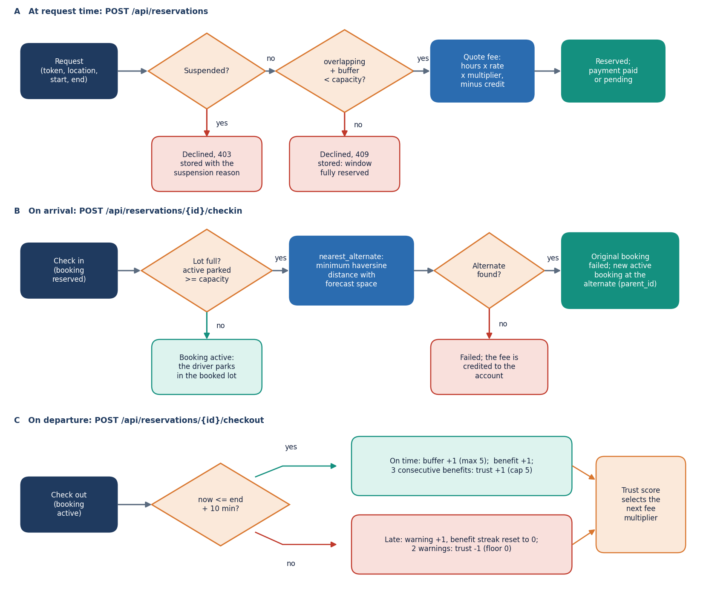
Figure 1: Flowchart of the Smart Availability Engine: suspension check, admission rule, fee quote, arrival check, nearest-alternate search, departure check, buffer growth and trust update.

1.2 Dataset
ParkSure is a rule-based system. It has no machine-learning model and no external dataset, so there is no training set, validation set or test set in the usual sense, and no dataset licence applies. Two kinds of data are used, and both are generated by the project itself.
The demo database is created on first start by app/seed.py with a fixed random seed (42). It contains 9 users (one administrator and eight drivers, two of whom have an overstay history), 5 locations in Bengaluru coordinates (20, 12, 15, 25 and 8 bays at 4.00, 3.00, 2.50, 5.00 and 2.00 dollars per hour), and 347 reservations spread over the last 60 days plus eight Friday-evening peaks at the smallest lot, which is deliberately over-subscribed so that the Strategy Insights page has contention to replay. Of the reservations, 279 are completed, 39 failed (unable to park) and 29 declined; 279 payments are paid. These records are synthetic. They demonstrate the mechanism; they are not observations of real drivers, and no conclusion about real parking behaviour may be drawn from them.
Table 2: The seeded demo database (fresh install, 2026-10-26).
Quantity | Value
Users | 9 (1 admin, 8 drivers); initial trust 2 for drivers 3 and 6, 4 for drivers 1 and 2, 3 for the rest, 5 for the admin
Locations | 5: Central Station Garage (20 bays), Market Street Lot (12), Riverside Parking (15), Airport Express Park (25), Old Town Deck (8)
Reservations | 347: 279 completed, 39 failed, 29 declined, 0 reserved
Payments | 279, all paid, provider demo
History | 60 days of 2 to 5 requests per day, plus 8 weekly Friday-evening bursts at Old Town Deck
Split | None: there is no model to train, so nothing is held out

The simulator scenario is the second data source. It re-creates the experiment of [2]: 8 parking areas of 10 bays, 80 to 110 vehicles, each making 10 parks of 1 to 3 hours, 25 to 50 percent of the vehicles leaving one hour late, and two stops of 8 to 16 hours outside the system. The base paper ran it in the SUMO traffic simulator [21]; ParkSure's simulator is a discrete-event program, not SUMO, and the parameters the paper does not state (arrival process, lead time, gaps, area choice) are assumptions listed in Section 6.6.
Seeded data are used for the product demonstration, the Strategy Insights replay and the screenshots. The simulator output is used for the buffer comparison in Chapter 8. Neither is real-world evidence, and each report section that uses them says so.

1.3 Input handling and preprocessing
There is no feature extraction, but every request is cleaned before it touches the rules. Four steps do that work.
• Schema validation (pydantic). A name must have 2 to 120 characters, an e-mail must be valid, a password 6 to 128 characters; a location needs a latitude in [-90, 90], a longitude in [-180, 180], a capacity from 1 to 5,000, an hourly price from 0.50 to 100 and a buffer from 0 to 20; a reservation needs a location id of at least 1 and an end time later than the start time. A violation returns 422 with the offending field.
• Normalisation. E-mail addresses are stored in lower case and compared case-insensitively; every timestamp is made timezone-aware in UTC with ensure_tz before it is compared, so a naive time from the database and an aware time from the browser can never be mixed. The console sends ISO-8601 strings converted from the browser's local time.
• Window rules. A window is a half-open interval. Search and reservation reject windows longer than 30 days (400). Billing uses at least 0.25 hours, so a one-minute booking costs a quarter of an hour.
• Seeding. On first start the lifespan hook creates the tables and, if the location table is empty, runs the seeder described in Section 6.2. A repeated start does not seed again; deleting parksure.db restores the demo state.
Two things are not checked. A reservation may start in the past (the probe in Chapter 7 shows a window two days ago was accepted), and check-in is not restricted to the booked window (a booking 25 days ahead could be checked in at once). Both are listed as limitations.

1.4 Algorithm choice and justification
The literature offers several ways to allocate parking. The table below sets them against the requirements of this project: a general platform for ordinary urban lots, with a fixed price, no sensors, a response time in milliseconds and rules a driver can understand.
Table 3: Alternatives considered and the reason for the choice.
Approach | Source | What it needs | Decision for ParkSure
Interval-overlap admission with a hold-back buffer | [7], [2] | Booking intervals and a capacity | Chosen: one count and one comparison per request; the buffer absorbs overstays
Auction-based allocation (ASAP, MaPark, bidding) | [5], [6], [8] | Bidding agents or a central auctioneer | Rejected: prices should be fixed and visible before booking
Multi-objective integer programming | [12] | Distances, congestion model, a solver | Rejected: needs inputs and run time that an ordinary lot does not have
Passenger-count grouping heuristics | [1] | Passenger counts, sensing, zone structure | Not adopted: solves zone load balancing inside one facility, a different problem
Deposit to deter false bookings | [11] | Partial payment | Not adopted: the Trust Score prices behaviour instead
Nearest alternate by great-circle distance | [2], [10], [23] | Coordinates of each lot | Chosen: no routing service, one decision, deterministic

Why interval overlap. Counting overlapping reservations is exact for the question 'will a bay be free at the start of this window if everyone leaves on time', it is linear in the number of bookings at one location, and it is the basic form of interval scheduling [22]. Its weakness is the one named by [2]: an overstaying driver breaks the assumption. Why a buffer. A buffer of bays that are never booked in advance but remain physically available turns that weakness into a controllable margin: a larger buffer refuses more requests and protects more arrivals. Why one nearest alternate. The paper argues that a second suggestion would usually be too far from the driver's destination; the code follows that rule. Why a Trust Score. A star rating that moves slowly (three benefits for a point, two warnings to lose one) gives a price signal and a last-resort sanction without any hardware. None of these choices is claimed to be optimal; Chapter 8 measures what each one does and where the shipped version departs from the paper.

1.5 Mathematical formulation
Let a location l have capacity C, buffer b and hourly price p. A booking r has window [s_r, e_r) and status in {reserved, active} while it holds a bay. For a request with window [s, e):
O(l, s, e) = | { r at l : status(r) ∈ {reserved, active}, s_r < e, e_r > s } | (1)
admit(l, s, e) ⇔ O(l, s, e) + b < C bookable(l, s, e) = max(0, C − b − O(l, s, e)) (2)
The search route reports bookable(l, s, e) and the available flag (bookable > 0), which is equivalent to the admission inequality. The fee uses the duration h = (e - s) in hours and the multiplier m of the driver's rounded Trust Score τ:
fee = round( max(0.25, h) × p × m(τ), 2 ) m = {0: 1.75, 1: 1.50, 2: 1.25, 3: 1.00, 4: 0.95, 5: 0.90} (3)
Account credit c is applied before payment: credit used = min(c, fee), amount due = fee minus credit used. On arrival at location l the engine counts the active bookings A(l) and, if A(l) ≥ C, selects the alternate with the smallest haversine distance [23] among the locations whose own admission rule accepts the window:
d = 2R · arcsin( √( sin²((φ₂ − φ₁)/2) + cos φ₁ · cos φ₂ · sin²((λ₂ − λ₁)/2) ) ), R = 6371 km (4)
alternate = argmin d(l, l′) over l′ ≠ l with admit(l′, s, e) (none: booking fails, fee credited) (5)
At check-out at time t_out the departure is on time if t_out ≤ e + 10 minutes. With cap B_max = 5 and initial buffer b₀ = 1 the buffer update is b := min(b + 1, B_max) after an on-time departure, and b := b₀ once 24 hours have passed since the last reset (the scheduler checks every 30 minutes). The Trust Score τ, the benefit streak u and the warning count w, with B = 3, W = 2, τ in [0, 5] and the initial τ = 3, change as follows:
on time: u := u + 1; if u ≥ 3 then τ := min(τ + 1, 5) and u := 0 (6)
late: u := 0; w := w + 1; if w ≥ 2 then τ := max(τ − 1, 0) and w := 0 (7)
A driver is refused when the suspension cooldown is running, or when τ < 1.5 and a warning event was recorded within the last 14 days; in the second case a 24-hour cooldown is started. Because the check is repeated at every request and a refused request records no new benefit, a driver whose score has fallen below 1.5 cannot recover it by booking, so the practical lockout lasts until the last warning is 14 days old.

1.6 Engine parameters, simulator and parity check
In place of a trained model, ParkSure has a small set of policy parameters, all set in app/config.py and overridable by environment variables. They are fixed during every measurement in this report.
Table 4: Policy parameters of the Smart Availability Engine.
Parameter | Value | Meaning
BUFFER_INIT / BUFFER_MAX / BUFFER_RESET_HOURS | 1 / 5 / 24 | Initial buffer, cap, and the interval after which the scheduler resets it
Scheduler interval | 30 minutes | How often the reset job checks every location
BENEFIT_STREAK_FOR_REWARD (B) / WARNINGS_FOR_PENALTY (W) | 3 / 2 | Benefits needed for +1 trust; warnings that cost -1
TRUST_START / TRUST_MIN / TRUST_MAX | 3.0 / 0 / 5 | Trust range
TRUST_SUSPEND_THRESHOLD / RECENT_VIOLATION_DAYS / SUSPEND_COOLDOWN_HOURS | 1.5 / 14 / 24 | Suspension rule
FEE_MULTIPLIER | 1.75, 1.50, 1.25, 1.00, 0.95, 0.90 | Multiplier for trust 0 to 5
On-time grace | 10 minutes | Hard-coded in the check-out route
Booking length limit | 30 days | Hard-coded in _require_future_window

Simulator configuration. scripts/parking_sim.py is a discrete-event simulator with three event types: request, arrival and departure. It uses the engine's pure functions directly and re-implements the stateful rules (admission, trust update, suspension) on plain numbers. Each experimental cell runs 30 seeds (the paper used 5). The settings fixed before the runs were:
Table 5: Simulator settings and the assumptions the base paper does not state.
Setting | Value
Areas and bays | 8 areas x 10 bays, on a 4 x 2 grid 0.012 degrees (about 1.3 km) apart
Population and behaviour | 80, 90, 100 or 110 vehicles (or a random 80 to 110); 25 to 50 percent leave one hour after the reserved end
Parks per vehicle | 10, each planned for 1 to 3 hours; two stops of 8 to 16 hours outside the system
Assumed by the project | Reservation placed 15 to 60 minutes before arrival; next request 15 to 60 minutes after leaving; uniform choice of area; first request within 2 hours; every driver checks in on time
Policies compared | Static buffer 0, 1 and 3; dynamic as shipped (grows on an on-time departure); dynamic as in the paper (grows on a late departure); each with the Trust Score on or off
Outcomes counted per run | Refused by admission (no reservation), refused by suspension, moved to an alternate, alternate physically full, no park, success rate, bay utilisation

Parity check. A simulator is only evidence if it behaves like the product. scripts/parity.py feeds the same random inputs to the simulator's rules and to the real engine functions on an in-memory database and compares every decision: 2,000 admission decisions, 8,000 trust updates and 300 suspension decisions, 10,300 in all, with 0 mismatches. The same check runs as 5 tests in tests/test_sim_parity.py. What the parity check does not cover is the arrival and alternate logic, which the simulator mirrors by reading the code, and the scheduler's 30-minute granularity, which the simulator approximates by resetting at the first event after 24 hours.
Cost of the decisions. On an in-memory database with 5,000 reservations, the admission decision takes 0.3337 ms on average (p95 0.4573 ms), one haversine distance takes about a microsecond, and the nearest-alternate search over 49 other locations takes 18.623 ms (p95 23.4802 ms) because it runs one overlap query per location.
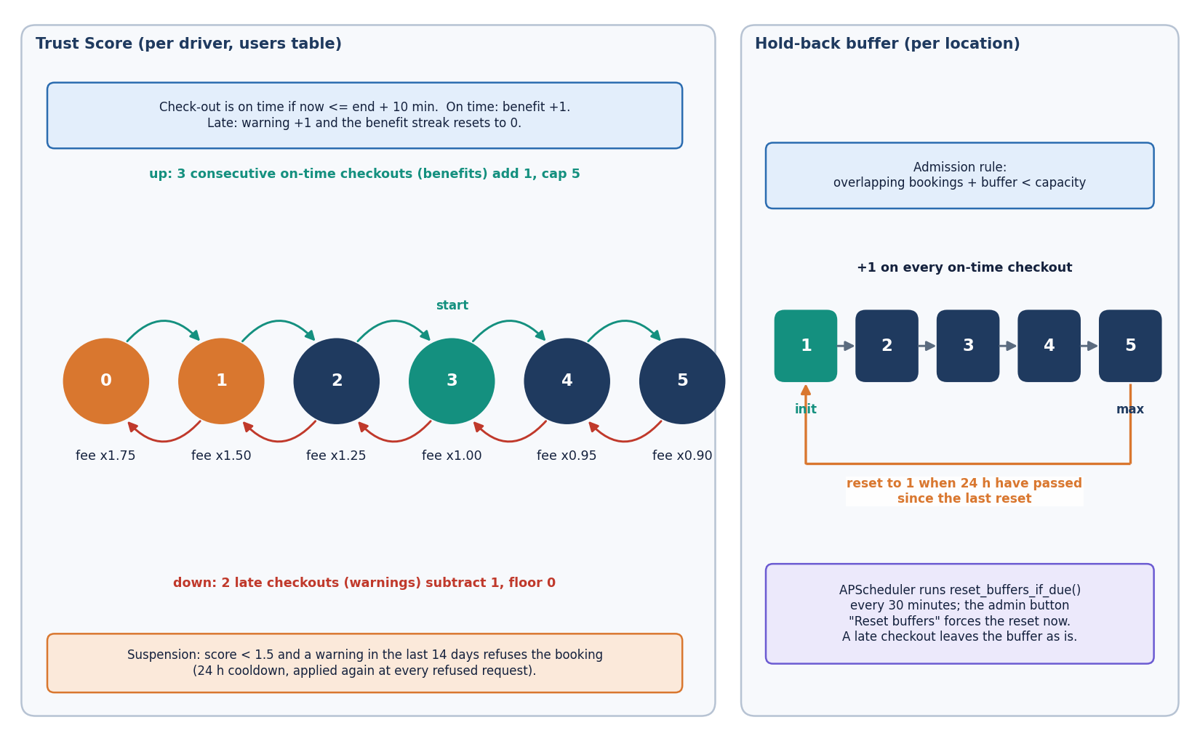
Figure 2: Trust Score and buffer policy of ParkSure.
Figure 3: Flowchart of the core algorithm of the Smart Availability Engine.

2. NOVELTY AGAINST THE BASE PAPER

2.1 What the base papers contribute
The registered base paper [1] treats parking inside a large managed facility, a medical city. It allocates vehicles to parking spaces by the total number of passengers rather than the number of vehicles, through a four-stage grouping procedure and six grouping-permutation heuristics, and describes an architecture of booking interfaces, QR validation, gate and in-space sensing and a central allocation engine. It is evaluated on nine instance classes with 2,790 generated test cases. Its best algorithm reaches the highest best-solution share (68.2 percent), and the variant GVb matches or beats the baseline MR on 1,547 instances (55.4 percent: 57 better, 1,490 equal), in sub-millisecond time. It does not cover online payment, overstay handling, driver reputation or operator analytics.
The paper [2] whose rules ParkSure implements addresses the situation where a reserved bay is still occupied when the next driver arrives. It proposes a reservation module with a buffer of non-reservable bays and a reward system with a 0 to 5 star reputation. It is evaluated only in a SUMO simulation of 80 spots in 8 areas, with 80 to 110 vehicles of which 25 to 50 percent overstay by one hour, over five runs, and its results are given as figures: any buffer beats none and the dynamic buffer gives the best trade-off. The authors describe the work as preliminary.

2.2 What is new in ParkSure
• A complete operating platform rather than an algorithm or a simulation. Neither base paper delivers a web application. ParkSure combines search, advance booking, payment, check-in and check-out, role-based administration and 24 captured screens in one FastAPI and React system with 22 routes and 5 tables, covered by 70 passing tests.
• The buffer and star ideas of [2] turned into product rules. The hold-back buffer, the benefit and warning counters, the fee multiplier from the trust score and the suspension rule are implemented in app/engine.py and reachable through the API and the interface.
• Nearest-alternate re-allocation with automatic credit. When a lot is physically full at check-in the engine selects exactly one other location with forecast space by haversine distance, books it as an active alternate linked to the original booking, or marks the booking failed and credits the fee to the driver's account.
• Operator analytics by deterministic replay. Strategy Insights replays the stored booking history under four buffer policies and compares unable-to-park and declined counts per location, so an operator sees the trade-off on their own data.
• A measured and verified evaluation. A discrete-event simulator re-creates the scenario of [2] with the ParkSure rules and agrees with the real engine on 10,300 checked decisions (0 mismatches). Latency, a concurrency probe and security probes were run on the product itself, and the defects they exposed are reported rather than hidden.

2.3 What is standard
Interval-overlap admission [22], the haversine distance [23], JSON Web Tokens [25], bcrypt password hashing [26], a relational schema through an object-relational mapper [27], REST routes [24] and hosted card checkout [29] are established techniques used as they are. The idea of reserving ahead and holding a safety margin is the one proposed in the paper above, and the same family of reservation platforms is surveyed in [3], [19].

2.4 What the base papers have and ParkSure does not
• No passenger-aware grouping or load balancing. ParkSure allocates by capacity and time overlap only, so it does not implement the algorithms of [1] and makes no claim to match or beat them. The two works solve different problems and use different data, so their numbers cannot be compared.
• No sensors, cameras or QR gates. Occupancy is software-managed through Check In and Check Out buttons; availability is a forecast from bookings, not a live reading.
• No SUMO run. The simulator in scripts/parking_sim.py follows the scenario of [2] but is not SUMO, and several of its parameters (arrival process, lead time, gaps) are assumptions because the paper does not give them.

2.5 Where the shipped rule departs from the paper
The paper grows the buffer when a vehicle leaves after its reservation ends, so that places prone to late departures hold more bays back. The shipped code grows it on every on-time checkout (app/main.py, route checkout), with the comment that the buffer grows as on-time behaviour is observed. Both rules were measured. At 100 vehicles with 25 percent overstaying, the shipped rule refused 277 of 1000 requests, the paper-literal rule 165, a static buffer of 3 refused 158 and no buffer 30. The shipped direction is therefore the most conservative of the five, and the conclusion of the paper that a dynamic buffer gives the best trade-off is not reproduced for it. The code was not changed; the difference is reported as a finding.

3. KEY CONTRIBUTIONS
The contributions of the project, stated at the strength the evidence supports, are:
1. A working reservation platform, ParkSure: registration and login with roles, availability search by time window, advance booking with a forecast-based admission rule, fee quoting, Stripe test-mode and demo payment, cancellation with account credit, check-in and check-out, and an administrator console, served by 22 routes over 5 tables and a React interface with 24 captured screens.
2. A Smart Availability Engine that implements the hold-back buffer, the nearest-alternate search by haversine distance, the Trust Score with fee multipliers and the suspension rule of [2] in 141 lines of Python that are unit-tested.
3. A parity-tested simulator that re-creates the base paper's scenario with the ParkSure rules and matches the engine on 10,300 decisions with 0 mismatches, and an experiment harness that compares five buffer policies over 30 runs per cell, with and without the Trust Score.
4. Findings the shipped behaviour would have hidden: the shipped buffer rule is the most conservative of five; failures at the gate are rare because the alternate step absorbs them, but alternates can themselves be physically full; the Trust lockout, not the buffer, causes most refused requests when a quarter of drivers are bad.
5. An honest defect list from the team's own probes: a booking race that over-booked one of ten trials, an unauthenticated demo-payment endpoint, a default token secret, no login rate limit, and per-row queries that make two list routes slow.
6. A reproducible artefact: 70 pytest tests, a 27-check smoke test, a screenshot script that drives the real interface, and scripts that regenerate every metric file and the facts file.

